A000-AFR-EGY-Ushabti-Green Faience-18th dynasty_1550-1295 BCE

Ushabti-Green Faience-18th dynasty_1550-1295 BCE

**Case no.:**

**Accession Number:**

**Formal Label:** Ushabti-Green Faience-18th dynasty_1550-1295 BCE

**Display Description:**

During the New Kingdom (1539–1075 BCE) funerary figurines resembled the tomb owner bearing the owner’s name. In this Ushabti the Wedjat or protective eye of Horus is painted on the chest and two reeds with an “I” sound encapsulate the sign to live. The sense of this inscription suggests that the deceased exhorted Horus to protect his or her mummy to live in the hereafter.

**LC Classification:** DT62

**Date or Time Horizon:** 18th dynasty_1550-1295 BCE

**Geographical Area:** Amarna

**Map:**

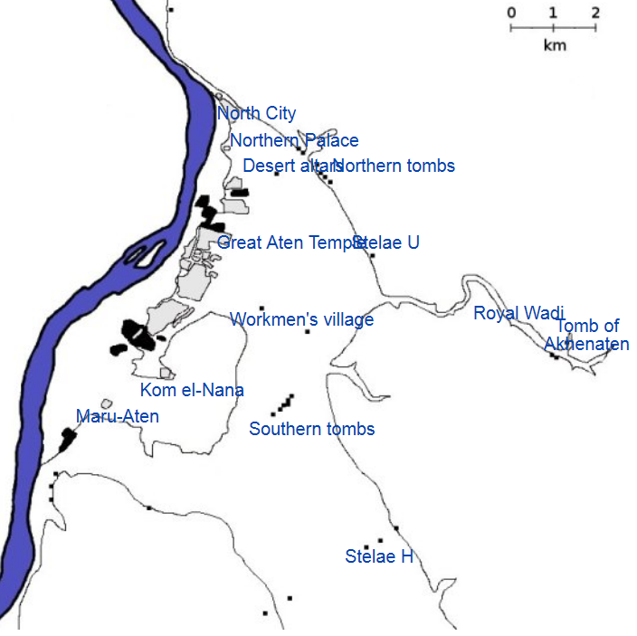

**GPS coordinates:**

**Cultural Affiliation:**

**Media:**

**Dimensions:**

**Weight:**

**Condition:**

**Provenance:**

**Discussion: after wikipedia**

Construction of Amarna started in or around Year 5 of Akhenaten’s reign (1346 BC) and was probably completed by Year 9 (1341 BC), although it became the capital city two years earlier. To speed up construction of the city most of the buildings were constructed out of mud-brick, and white washed. The most important buildings were faced with local stone (Grundon 2007: 89).

It is the only ancient Egyptian city which preserves great details of its internal plan, in large part because the city was abandoned after the death of Akhenaten, when Akhenaten's son, King Tutankhamun, decided to leave the city and return to his birthplace in Thebes (modern Luxor). The city seems to have remained active for a decade or so after his death, and a shrine to Horemheb indicates that it was at least partially occupied at the beginning of his reign,if only as a source for building material elsewhere. Once it was abandoned it remained uninhabited until Roman settlement began along the edge of the Nile.

**References:**

Aldred, Cyril. 1988. *Akhenaten: King of Egypt*. London: Thames and Hudson.

David, Rosalie. 1998. *Handbook to Life in Ancient Egypt*. New York: Facts on File.

de Garis Davies, Norman. 1903–1908. *The Rock Tombs of El Amarna*. Part 1–6. London: EES.

Grundon, Imogen. 2007. *The Rash Adventurer, A Life of John Pendlebury*. London: Libri.

Hess, Richard S. 1996. *Amarna Personal Names*. Winona Lake, IN: Dissertations of the American Schools of Oriental Research - DASOR, 9.

Kemp, Barry. 2012. *The City of Akhenaten and Nefertiti. Amarna and its People.* London: Thames and Hudson.

Martin, G. T. 1989 [1974]. *The Royal Tomb at el-'Amarna*. 2 vols. London: EES.

Moran, William L. 1992. *The Amarna Letters*. Baltimore: Johns Hopkins University Press.

Redford, Donald.1984. *Akhenaten: The Heretic King*. Princeton: Princeton University Press.

Waterson, Barbara. 2002. *Amarna: Ancient Egypt's Age of Revolution*. London: Tempus.